KAMPALA JUNIOR ACADEMY
HOLIDAY WORK SET THREE TERM I 2020
PRIMARY TWO
ENGLISH

My name is ________________________________________________
School _____________________________________________________


1. Name these objects.
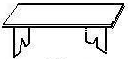 | 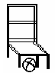

2. Make short words from the long ones.
(a) weather ________________________
(b) father ________________________
(c) carpenter ______________________

3. Arrange these words in alphabetical order.
(a) flag, badge, motto, signpost
___________________________________________________
(b) rubber, pencil, book, desk
___________________________________________________
4. Give the opposite of each underlined word.
(a) My aunt is very busy. ____________________
(b) We shall go to school. _______________________
(c) Jane’s uniform is dirty. ________________________

5. Complete the table below correctly.
(a) | young | ________________ | youngest
(b) | happy | Happier | ________________
(c) | ______________ | fatter | fattest

6. Answer Yes, it is/No, it is not.


(a) Is this a pencil? ___________________

(b) Is this a tree? _____________________
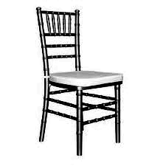
(c) Is this a bench? ___________________

7. Fill in the gap with a correct word from the brackets.
(a) We ________________ rice everyday. (it, eat)
(b) The __________________ gives us light. (son, sun)
(c) A cow has __________________ legs. (four, for)

8. Give the plural of the word in the brackets.
(a) Dad bought many ________________. (mango)
(b) Mary has two _________________. (book)
(c) A cow has three ________________ (calf)
(d) The _______________ are playing. (baby)

9. Match the nouns with pronouns.
Noun Pronoun
- House they
- Father she
- Aisha it
- John and Sarah he
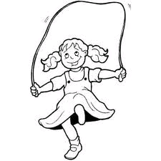
10. Make a good sentence about the picture.
(a) ___________________________________________

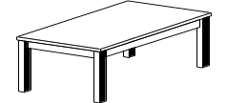
(b) ___________________________________
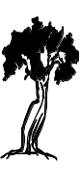
(c) ___________________________________________
(d) ___________________________________________

11. Fill in “has” or “have”

- John ______________ many cows on his farm.
(b) Those children _________________ eaten all the food.
(c) I ______________ to visit my mother today.

12. Fill in “a” or “an” to complete the sentence.
(a) He was knocked down by ______________ car.
(b) Cathy bought _____________ umbrella.
(c) The cat has _____________ long tail.

13. Write in full.
(a) Rd. ______________________
(b) Dr. _____________________
(c) Sch. ______________________

14. Join to form compound words.
(a) sick mat (a) ____________________
(b) ink bay (b) ____________________
(c) door glasses (c) ____________________
pot

15. Fill in the correct word from the list.
bigger, longer, shorter, taller

A
B
(a) Tin A is ________________ than tin B.

(b) The girl is ______________ than the boy.
(c) K Ruler K is ______________ than ruler M.
M

16. Join the sentences using and
(a) Rose can sing. Rose can dance.
___________________________________________________
(b) Linda is a girl. Betty is a girl.
___________________________________________________
(c) Tom has a pencil. Tom has a pen.
___________________________________________________

---END---

